Project 3: Slides: Differential Staining of Cells
Lab Main Page:
http://www.scienceprofonline.com/vmc/vmc-lab/vmc-laboratory-differential-staining-bacteria.html

Readings:
Links to the required readings can be found on VMC Main Page for this lab. See class schedule for related textbook reading.
Purpose:
The purpose of this project is to (1) acquaint students with three common bacterial stains and their clinical uses and (2) acquaint students with the parts of the microscope and proper microscopy techniques.
Outcomes:

After you complete this lab you will be able to:
- Perform the Gram stain, acid-fast stain and endospore stain procedures.
- Prepare and stain the slides correctly.
- Use and interpret appropriate controls.
- Compare and contrast the clinical information gained from performing differential stains.
      - Identify major genera of bacteria that stain Gram-positive or Gram negative.
      - Identify major genera of bacteria that stain acid-fast or non-acid-fast.
      - Differentiate the major genera of bacteria that are endospore formers from the non-endospore formers.
      - Using the knowledge gained from the clinical specimen type and stain outcomes, narrow down the possibilities to major genera.
- Use a key to identify an “unknown” based on differential stain reactions.
- Consistently record the ID number of your “unknown” sample, and include it in all reports.
- Match the identity of an “unknown” correctly with the instructor’s answer key.
- Identify the parts of the microscope.
- Given a picture of a microscope, write in the names of the parts.
- Point to an item on the microscope and identify it.
- Use the microscope properly.
- Consistently focus the microscope properly.
- Consistently use the mechanical control adjustment to move the specimen on the slide.
- Properly use the iris diaphragm and/or condenser to adjust the amount of light illuminating the specimen.
- Consistently find, observe and draw or photograph specimens properly using low, high and oil immersion objectives.
- Consistently distinguish material for observation from any artifacts that may be present.
- Care for the microscope properly.
- Clean the microscope correctly after each use.
- Store the microscope properly after each use.
- Inspect stored microscopes to confirm proper storage.
- Apply terms used in the laboratory exercise.
- Write out the definition of all terms in the “Terms to Know” table below.
- Use all terms correctly and apply appropriate terms to specific techniques performed.
- Identify cellular components of human blood.
- Consistently distinguish between the eukaryotic cells in blood and the prokaryotic bacteria identified in later laboratory exercises.
Terms to Know:

Be able to define these terms and apply them in the laboratory.
acid-fast | E. coli | nosepiece
acid-fast bacilli | endospore stain | objective
acid-fast stain | field of view | ocular
Artifact | Gram stain | oil immersion
bacilli | Gram-negative | parfocal
bacillus | Gram-positive | positive control
Bacillus | Gram-variable | primary stain
Band | heat fix | refraction
Basophil | high dry power | resolution
clinical sample | immersion oil | S. epidermidis
Clostridium | iris diaphragm | scanning power
Cocci | low power | simple stain
colony forming unit | mordant | spore
compound light microscope | Mycobacterium | total magnification
counterstain | negative control | vegetative cell
differential stain | non-acid-fast | working distance

Introduction
In this lab, you will be given an unidentified bacterial culture. Your job will be to narrow down the possible identities. You will perform Gram, acid-fast and endospore stains on the unknown bacterium and include appropriate controls. You will then use microscopy techniques to determine the results of your stains and a key to narrow down the possible identities of your bacterium.
Gram Stain
In the late 1800s, Danish bacteriologist Hans Christian Gram developed a method for staining bacterial cells that seemed to separate the cells into two groups. These groups, known as Gram-negative and Gram-positive, were separated on the basis of the color of the bacteria after a series of stains were applied to them. The Gram-positive cells stain purple, and the Gram-negative cells stain red/pink; this makes the Gram stain a differential stain (i.e., it illustrates differences between bacterial cells). Today, the identification of an unknown organism begins with a Gram stain. The Gram stain quickly not only tells if a bacterium is Gram-positive or Gram-negative, but also allows you to see the shape of the bacterium (its cell morphology). Clinically, Gram stain results help facilitate rapid identification and intervention with appropriate antibiotics.
In this lab, you will perform a Gram stain, interpret the results and understand the theory behind it. For the Gram stain, as well as the acid-fast and endospore stains, you will first prepare a specimen of bacteria by placing bacteria on a slide, allowing them to dry and then heat fixing them. Once this dry mount is prepared, you may proceed with the staining procedure itself.
The Gram stain procedure involves first staining all cells purple with the primary stain, crystal violet. In the second step, the cells are treated with Gram’s iodine, which is a mordant. A mordant is a chemical that fixes in place a dye already present. In this case, the Gram’s iodine causes the crystal violet to clump together, or to precipitate. It is thought that this occurs in a layer of the cell wall called the peptidoglycan layer. Third, the cells are washed with acetone alcohol, which is able to wash the precipitated crystal violet out of Gram-negative cells, but not Gram-positive cells, perhaps because the thicker layer of peptidoglycan in the Gram-positive cells traps the precipitates. Fourth, the cells are counterstained with safranin. The Gram-positive cells retain their darker (purple) color; however, the decolorized Gram-negative cells clearly show the red/pink counterstain. A counterstain is a stain used to visualize cells that would otherwise have no stain at the end of a procedure. Without a counterstain, they would not be visible.

Acid-Fast Stain
The second differential stain you will perform is an acid-fast stain. This stain is used in the identification of bacteria of the genera Mycobacterium, which are bacilli. Mycobacterium tuberculosis is the causative agent of tuberculosis, and Mycobacterium leprae causes leprosy. The acid-fast stain is most commonly used on clinical samples of sputum when tuberculosis is suspected; this is its most important use. In lab we will use Mycobacterium smegmatis (M. smeg), a non-pathogenic bacterium in this genus. Mycobacterium bacilli have a cell wall that differs from both Gram-negative and Gram-positive bacteria. Mycobacterium cells can stain either Gram-positive or Gram-negative depending on the age of the culture. Thus, they are said to be “Gram variable.” The cell wall of Mycobacterium bacilli contains a waxy substance called mycolic acid. This waxy material makes it difficult to get stains into and out of Mycobacterium cell walls.
In an acid-fast stain, the primary stain, carbolfuchsin, is forced into the Mycobacterium cell wall with heat. In the second step of the acid-fast staining procedure, after cooling, the Mycobacterium cell walls are not easily decolorized with acid-alcohol; thus, they are said to be acid-fast. (An old term for “won’t fade in the wash” was color-fast.) Non-acid-fast bacteria decolorize under this rigorous regime. After the decolorization process, in the third step of the acid-fast staining procedure, the cells are counterstained with crystal violet. All cells that were decolorized will now stain blue/purple. These cells that decolorize with the acid alcohol are known as “non-acid-fast” bacteria.
Endospore Stain
Endospores are survival structures that can be made by two genera of bacteria. Members of species in the genera Clostridium and Bacillus sporulate to produce these unusually resistant, inert structures that house the bacterial chromosome when environmental conditions become harsh. When the vegetative (growing) cell is not capable of surviving in the harsh environment and is destroyed, the endospore waits out the inhospitable conditions. When the environment is once again friendly, the endospore germinates into a vegetative cell, much like a seed germinating in the spring.
Because the endospore is impervious to normal staining techniques, we will stain endospores using the Schaeffer-Fulton method, which relies on heat to force the primary stain (malachite green) into the stain-resistant endospore. Once the stain penetrates the endospore and the endospore is cooled, the stain will not wash out when the slide is rinsed with water. The vegetative cells are then counterstained using safranin. At the end of the staining procedure, the endospores are green and the vegetative cells are pink.
Endospore formers are culprits in many diseases and are a major nosocomial threat in clinical environments. Clostridium difficile, for example, is the most common cause of a serious diarrheal illness associated with antibiotic use.
Controls
Remember, a positive control is a known sample submitted to the procedures that will show you a positive answer. When you perform a Gram stain, you will always include samples of Staphylococcus epidermidis (S. epi), which is known to be Gram-positive, and Escherichia coli, which is known to be Gram-negative. Note that in this example, E. coli is used as a positive control even though it is a Gram-negative bacterium. If the Gram stain procedure works as it should, S. epi will be purple and E. coli will be pink. For stains and other procedures, positive controls also provide you with a basis of comparison and tell you if you performed the stain correctly. For example, most of you have not observed cocci and/or bacilli before. S. epi is a coccus and E. coli is a bacillus, so you can look at your unknowns and compare them to your controls to help you decide the shape, as well as the Gram-stain result, of the unknowns.
Again, recall, a negative control is a known sample that should show you a negative result. For example, if you performed the Gram stain procedures, but did not include the crystal violet and the safranin, you should not be able to see either pink or purple cells at the end of any of the steps. Negative controls alert you to reactions that should not be going on, but seem to be happening anyway. For example, when performing Gram stains, we have noticed that the clothespins used to hold the slides pick up rather large amounts of stain. When the slides are then washed with a decolorizer, the stain in the clothespins can be washed out of the clothespins and onto the cells, giving them a color they should not have. We will not routinely perform negative controls when doing differential stains in this laboratory, although we will use negative controls for other procedures. A combination of positive and negative controls can show you that everything went as expected in your experiment and you can trust your results. If there is something wrong with the controls in an experiment, you cannot use the results of the experiment.
Unknown Identification Number
When you are given an “unknown” culture of bacteria, it will be your responsibility to use these three stains to narrow down the possible identities of the “unknown.” The “unknown” is unknown only to you; your instructor knows its identity, and it is your job to determine its identity correctly based on the stains and other tests you perform. It is imperative that you record your “unknown ID number.” Your instructor will check the identity of your “unknown” for accuracy, and a large part of your grade will depend on the correct identification. You will lose a significant number of points if you fail to identify your “unknown.” (Failure to identify your “unknown” would be similar in clinical medicine to failure to correctly identify your patient!!)

PROCEDURES: Project 2
Slides: Differential Staining of Cells
Prepare Dry Mounts
You will each sample and stain a colony from the streak plate containing your unknown. Be sure to record your unknown’s ID number on your lab card, on today’s line. You will use aseptic technique, as outlined below, to transfer bacteria to a slide. You also will sample and stain positive controls. In this exercise, these will provide examples of both stain colors and bacterial shapes so you can compare your unknowns to these two samples.
M.
smeg
.
Unknown
# ______
S.
epi
Slide 2
M.
smeg
.
Unknown
# ______
S.
epi
Slide 2
S.
epi
Unknown
# ______
E. coli
Slide 1
Figure 3-1: Gram Stain Slide
S.
epi
Unknown
# ______
E. coli
Slide 1
Figure 3:
Endospore
B.
subtilis
Unknown
# ______
E. coli
Slide 3
Figure 3-3:
Endospore Slide
B.
subtilis
Unknown
# ______
E. coli
Slide 3
Figure 3-2: Acid Fast Slide
- Do this staining individually. You will need three slides. Check that they appear clean. Using a wax pencil, draw three circles about the size of a nickel on each slide. Also label your slides so that you know which is right and which is left, but do not label inside your circles. Turn the slides over so that the wax side is “down” and continue.
- Place a small drop of sterile water in each circle using a sterile loop.
a. Remove the cap and flame the top of a tube of sterile water.
b. Insert your sterile loop and retrieve a loopful of sterile water. The circle part of your loop should contain water, just like a bubble-blower contains soapy water when you blow bubbles. If you have difficulty picking up water, check that your loop is closed.
c. Place the water on the slide by touching the loop to the slide.
- Sterilize and cool your loop.
4. Transfer bacteria for the gram stain slide as indicated in Figure 3-1.
a. Gently touch an isolated colony of Staphylococcus epidermidis from a plate of bacteria. Transfer a very small amount of the organism with the inoculating edge of the transfer loop. (NOTE: When making smears from solid media, the most common error is the transfer of too much inoculum. If you have a dense white cloud on your slide, you have transferred too much and will be hunting all over for a sparse enough area in which you can see individual cells.)
b. Mix the bacteria well with the water in the circle on the left side of the slide, and spread the mixture over the entire circle area drawn.
c. Sterilize the loop. (Sterilize the loop each time you pick up or drop off bacteria. This may seem like overkill, but remember that if you transfer bacteria from your non-sterile slide to another plate, you will be transferring bacteria as well. Never pick up the loop to use it or put it down without flaming it first!)
d. Repeat steps 3-6 for the transfer of the other bacteria to your three slides. Note that you will use the same unknown in the center circle of each slide.
e. Allow the smear to dry completely.
f. Heat fix for five minutes by placing the slide on the slide rack of the Bacti-Cinerator® IV, cell-side up. Heat fixing (a) kills the bacteria and (b) coagulates their proteins so that they adhere to the slide or, heat fix by allowing the slide to dry completely on the bench top, and then passing the slide three times through the tip of the Bunsen burner flame.
5. Repeat steps 4 a through f for the acid fast stain. Use the bacteria indicated in Figure 3-2. Note the acid fast control is Mycobacterium smegmatis and the nonacid fast control is Staphylococcus epidermidis. When transferring Mycobacterium smegmatis to your slide you may note that it does not transfer as easily as the other bacteria with which you have worked. Compensate for this by transferring more of this bacterial colony than you have previously used.
6. Repeat steps 4 a through f to prepare a slide for endospore staining. (Figure 3-3) Note the endospore forming control is Bacillus subtilis and the non-endospore forming control is Escherichia coli.
Gram Stain
Place the slide on the staining rack in the sink or hold it with a clothespin. Flood it with the primary stain, crystal violet, and allow it to stand for one minute. Rinse the slide with gently running tap water to wash off the stain.
- Flood the slide with Gram's iodine solution and let it stand for one minute. Gently rinse with water. (The iodine is known as the mordant. It combines with the crystal violet to form a precipitate that is easily removed by alcohol from the cell walls of Gram-negative bacteria, but not those of Gram-positive bacteria.)
- Grasp the slide with a clothespin, tilt it on a 45° angle and carefully drip the decolorizing agent 95% acetone alcohol over it until no more purple dye runs off. This is a critical step. Thick smears will require more time (closer to 20 seconds) than thin ones (10-15 seconds). However, over-decolorization may result if too much time is allotted to this step.
- Flood the slide with safranin for one minute. Rinse and gently blot it dry with a paper towel. (Safranin is the counter stain. Its purpose is to stain all unstained cells red/pink. Because the Gram-negative cells were decolorized in step 3, they were colorless at the beginning of step 4 and will show the color of the safranin stain at the end of step 4.)
Acid-Fast Stain
- Notice that you are using different positive controls for the acid-fast stain. Since species of Mycobacterium are the only bacteria that are positive in the acid-fast stain, you must use one as a positive control.
- Located under the hood in the lab prep room, you will find a boiling water bath. Set your slide on the wire screen over the boiling water bath. Cover the smears with a strip of blotting paper; the paper should not extend beyond the edges of the slide.
- Saturate the paper with Ziehl's carbolfuchsin.
- Do not allow the slide to dry. If necessary, add more stain. Allow the staining to continue for three to five minutes. Remove the slide from the screen to a paper towel, and discard the blotting paper in the orange biohazard bag taped to the bench.
- Return to the lab, gently rinse the slide with tap water and then decolorize the smears for 10-30 seconds with acid alcohol. Exercise care so that the smear is not over-decolorized. Gently rinse the slide with tap water.
- Apply the counter stain crystal violet for 30-45 seconds, gently rinse the slide and blot it dry.
Endospore Stain
Located in the lab prep room, you will find a boiling water bath. Set your slide on the wire screen over the boiling water bath. Cover the smears with malachite green (no wicking paper this time). Steam the slide over boiling water for five minutes. If the stain boils off, add more.
  - Allow the slide to cool, and then gently rinse it with water for 30 seconds.
  - Counterstain the bacteria with safranin for about 30 seconds.
- Rinse the slide briefly with water to remove excess safranin, and gently blot it dry.
- If you do not finish examining your slides during the lab period, wrap them in a paper towel without removing the immersion oil, secure the package with tape and label with your name and the date. Place your slides in the “save” bin.
Examine Your Slides.
1. Use the directions from Project 1 or the laminated card in your lab drawer to review focusing procedures as needed.
2. Observe and record the results of the stained slides in the following manner:
(a) Observe the positive controls first (i.e., the gram positive Staphylococcus epidermidis and the gram negative Escherichia coli). Make certain your controls are correct. If they have not stained properly, discuss this with your instructor. If your controls are properly stained use the microscope camera to take a picture of each control.
1. Use the line function to point to a single cell.
2. Use the distance line function to measure the width of a cell.
3. Record the color of the cells in the stain, just in case the color is not obvious in your photograph.

(b) Observe and record the results of the unknown bacterium you were assigned. Again, take a picture of your field of view.
(c) Save all your slides until you have completed your observations and analyzed your results.
(d) At the appropriate time, discard your stained slides in the disinfectant tray on your bench.
(e) Figure 3-5 below provides a guide to the data presentation for your lab report
3. Repeat the focusing procedure as you make observations and photographs from your acid fast and endospore stain slides.
4. Practice interpreting the stains.
a. Place the pointer on one cell or endospore.
b. Using a 3 x 5 note card, write the number of your lab bench in the upper left corner. Write a question regarding the item under the pointer (i.e. “Identify this Gram stained cell” or “identify this item in a staining process that uses carbol fuchsin as the primary stain”) Write the answer to your test item on the back side of the card.
c. Investigate at least five stations set up by your peers in the laboratory. Record your responses for inclusion in your lab report. If you should respond incorrectly, try to figure out what led you to the wrong conclusion and how you would interpret things differently, next time. You should probably devise a table for including these results in your lab report. Your table may look something like this:
Table 3.4: Results of Stain Interpretation Practice
Station Number | My Response | Correct Response | If incorrect, the corrective action I would take
17 | Gram negative cocci | Gram positive cocci | Observe the Gram positive control of S. epidermidis

5. Storing the microscope
When putting your microscope away, you need to be sure it is in proper storage order. Proper storage order consists of the following:
a. The microscope stage is clean.
b. The oil is cleaned from the oil immersion lens and all other parts of the microscope.
c. The 4X objective is clicked into place.
d. The finger cot is covering the 40X objective.
e. The stage is in the lowest possible position.
f. The dust cover is on.
g. The cord has been returned to the drawer.
Return your microscope to the proper storage space in the microscope cabinet.
Figure 3-5: Prototype of report for all laboratory stains

A
Figure 1: Gram Stain (A) Escherichia coli Gram negative bacilli control; (B) Unknown #19 (C) Staphylococcus epidermidis Gram positive cocci control
1000X
;cschauer

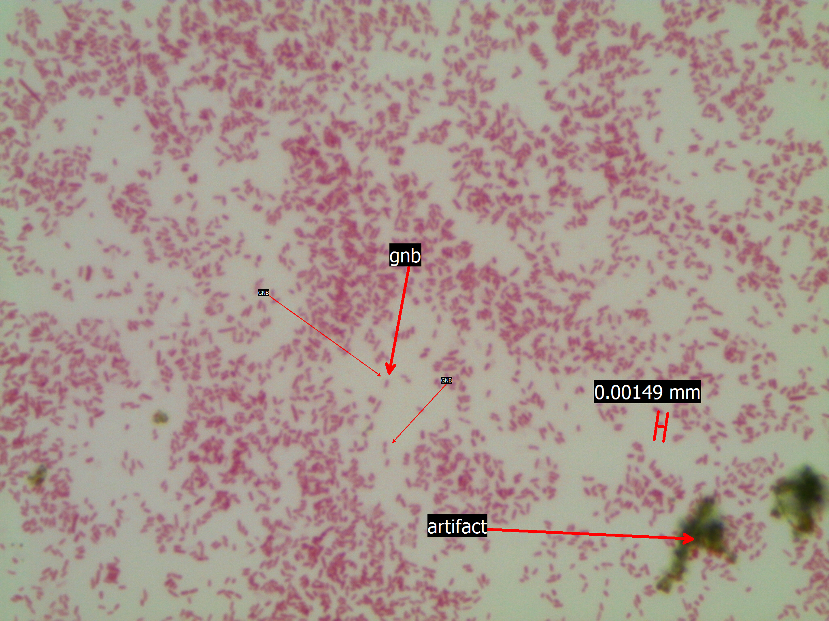

C
B

Assessment:
In order to get the most from your lab experience, it is very helpful to write the introduction to your Lab Report BEFORE you attempt the lab. In this process you read about the subject matter, in this case differential stains of bacteria, so you know something about what you will attempt in lab. Also included in this lab report are 9 pictures you took during the lab, an analysis of the near identity of your unknown, and one citation.

- Introduction
Read the lab handout, textbook selections, and lecture notes. Distill this information to write the laboratory introduction. The introduction should be at least 4 paragraphs and include the following items:
- An introductory paragraph using the classic inverted triangle style. Broadly introduce the reasons for performing the lab exercise and what you will be doing. Explain why the exercise is important or what you hope to gain from it. The final statement should outline what you will discuss in the successive (3) paragraphs. These topics should be the 3 stains you will perform.
- The second paragraph should contain information regarding the use of the Gram stain, the theory of the Gram stain (how you do it and why it works), and the controls used and how they should stain.
- The third paragraph should contain information regarding the use of the acid fast stain, the theory of the acid fast stain (how you do it and why it works), and the controls used and how they should stain.
- The fourth paragraph should contain information regarding the use of the endospore stain, the theory of the endospore stain (how you do it and why it works), and the controls used and how they should stain.
- You will need to cite at least one source using APA formatting. (HINT: If you are using Word, select the ‘References’ tab. insert citation, add new source and choose the appropriate item from the drop down menu. Then, fill out the rest of the information. At the end of the report select the bibliography tab and insert your works cited.)
- Data
Usie the prototype for pictures provided in Figure 3.5, to display your data.
- Analysis
Use the following statement to analyze your results:
Unknown number __________ is a Gram __________, acid fast/non acid fast, endospore forming/non-endospore forming, _____________(insert cell morphology). Based on this information, my unknown may be :
- Conclusion
- References
You will also receive points for bolded headings, correctly using the APA format for inserting figures, using proper grammar/spelling, and citing your work using at least three citations.

